**Resource 1: *Key questions***

**1. What information might researchers collect   
about young people and how might they do this?**



**2. Who might collect information about young   
people and how might this information be used?**



**3. If young people participate in research, how   
might that affect communities and society?**



**4. How might the topic of consent link to   
gathering research?**



**5. What rights might young people have when   
taking part in research and what might be   
done by researchers to respect these rights?**



**6. What can young people do if they have concerns  
about research they’re asked to take part in?**



**Resource 2: *Information sheets***

**What data might be collected about young people?**

Young people might take part in research on their attitudes, opinions and preferences, e.g. which apps they like most.

Data might be collected on the health services young people use and need, and what they do to keep themselves healthy.

Young people might be involved in research about their lived experiences (e.g. experiences   
of school or relationships).

The Smoking, Drinking and Drug Use among Young People in England survey asks about tobacco, vaping, alcohol and drug use.

**Resource 2: *Information sheets***

**Who might collect data about young people?**

Medical researchers and health services might want to know more about young people to help address their health needs.

Businesses, websites and social media platforms may want to know how to market products   
to young people.

Other researchers might include young people in research to understand what they need   
to support their wellbeing.

Schools collect data about young people to inform what they teach students and how much progress they’re making.

The Smoking, Drinking and Drug Use among Young People in England survey is carried out by an independent research organisation called **Ipsos** and data is shared with **NHS England.**

**Resource 2: *Information sheets***

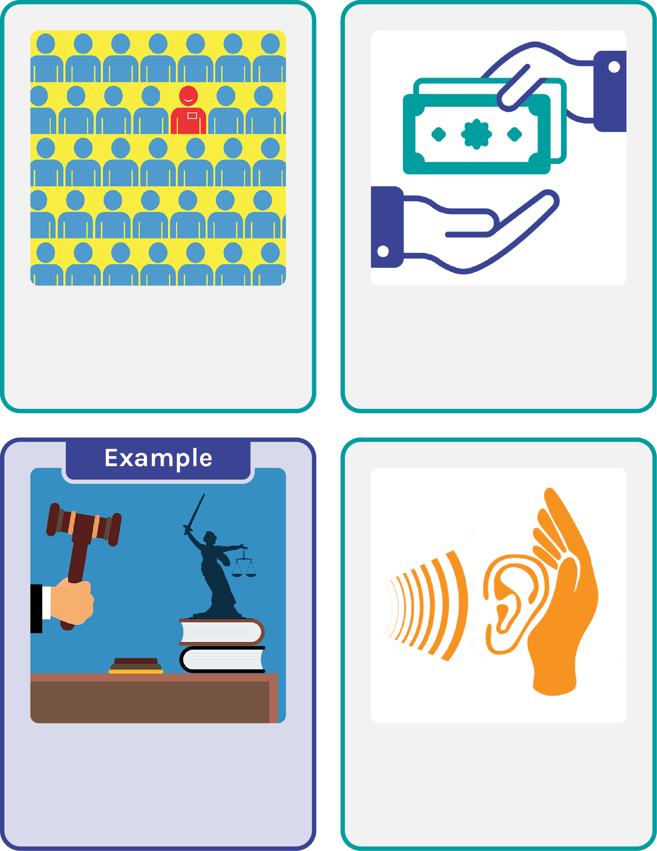**What benefits are there to young people participating   
in research?**

Involving young people   
in research can reduce stereotyping or assuming all young people’s needs are the same.

People use data to make decisions about services and funding, so they can use research to better consider young people’s needs.

The Smoking, Drinking and Drug Use among Young People in England survey helps to check that laws protect young people, and that smoking and drug services meet their needs.

Taking part in research can make people feel heard and empowered, and like they can help make a difference.

**Resource 2: *Information sheets***

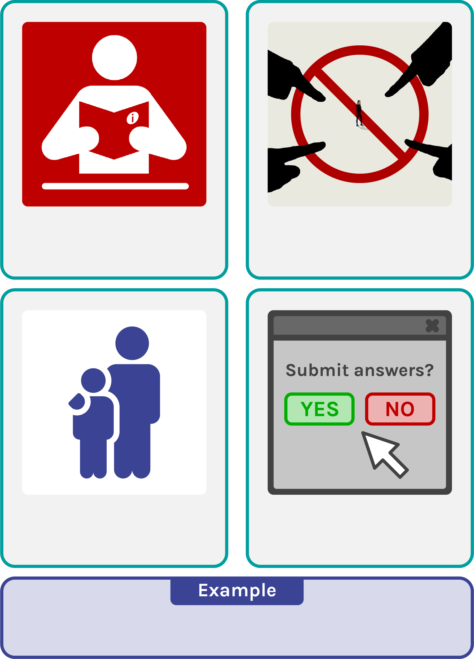**How does consent link to research?**

Informed consent is needed for research, this means someone has the information they need to make a decision.

Young people shouldn’t be pressured to take part in studies if they don’t want to.

Because of their age, young people might need an adult like a parent or headteacher to give permission for them to take part in a study.

Researchers should tell people how to withdraw their consent if they change their mind about a study.

e.g. by not submitting their data.

In the Smoking, Drinking and Drug Use among Young People in England survey participants can stop at any point to withdraw consent. However, submitted answers cannot be withdrawn because no personal data is collected to identify them.

**Resource 2: *Information sheets***

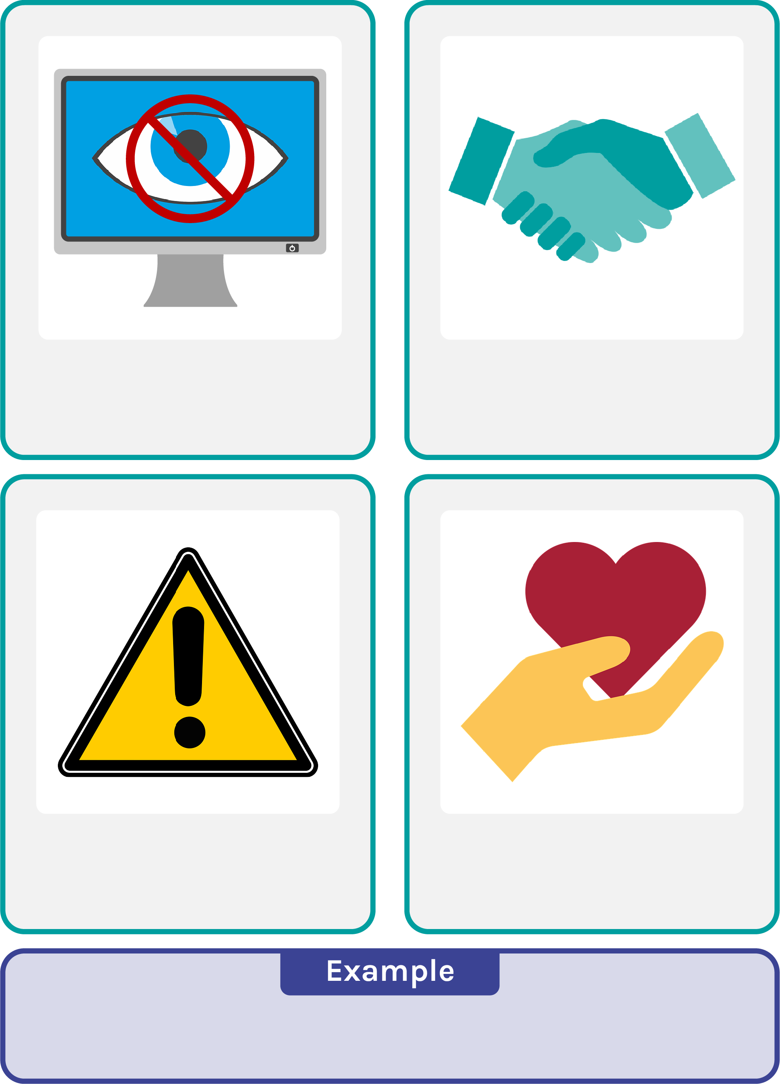**What rights do young people have when participating   
in research?**

Young people have the right to privacy and confidentiality if they take part in research.

Researchers should be respectful towards participants and ideally research should benefit participants.

Ethics boards are used in research to check studies are likely to be physically safe for participants and that participants know of any risks.

Ethics boards might also consider whether a study keeps participants ‘emotionally’ safe, and that it isn’t likely to be really upsetting or scary.

In the Smoking, Drinking and Drug Use among Young People in England survey participants privacy is respected by providing a whole class link to an online survey rather than individual links. This means the answers are anonymous.

**Resource 2: *Information sheets***

**What can young people do if they have concerns   
about a study?**

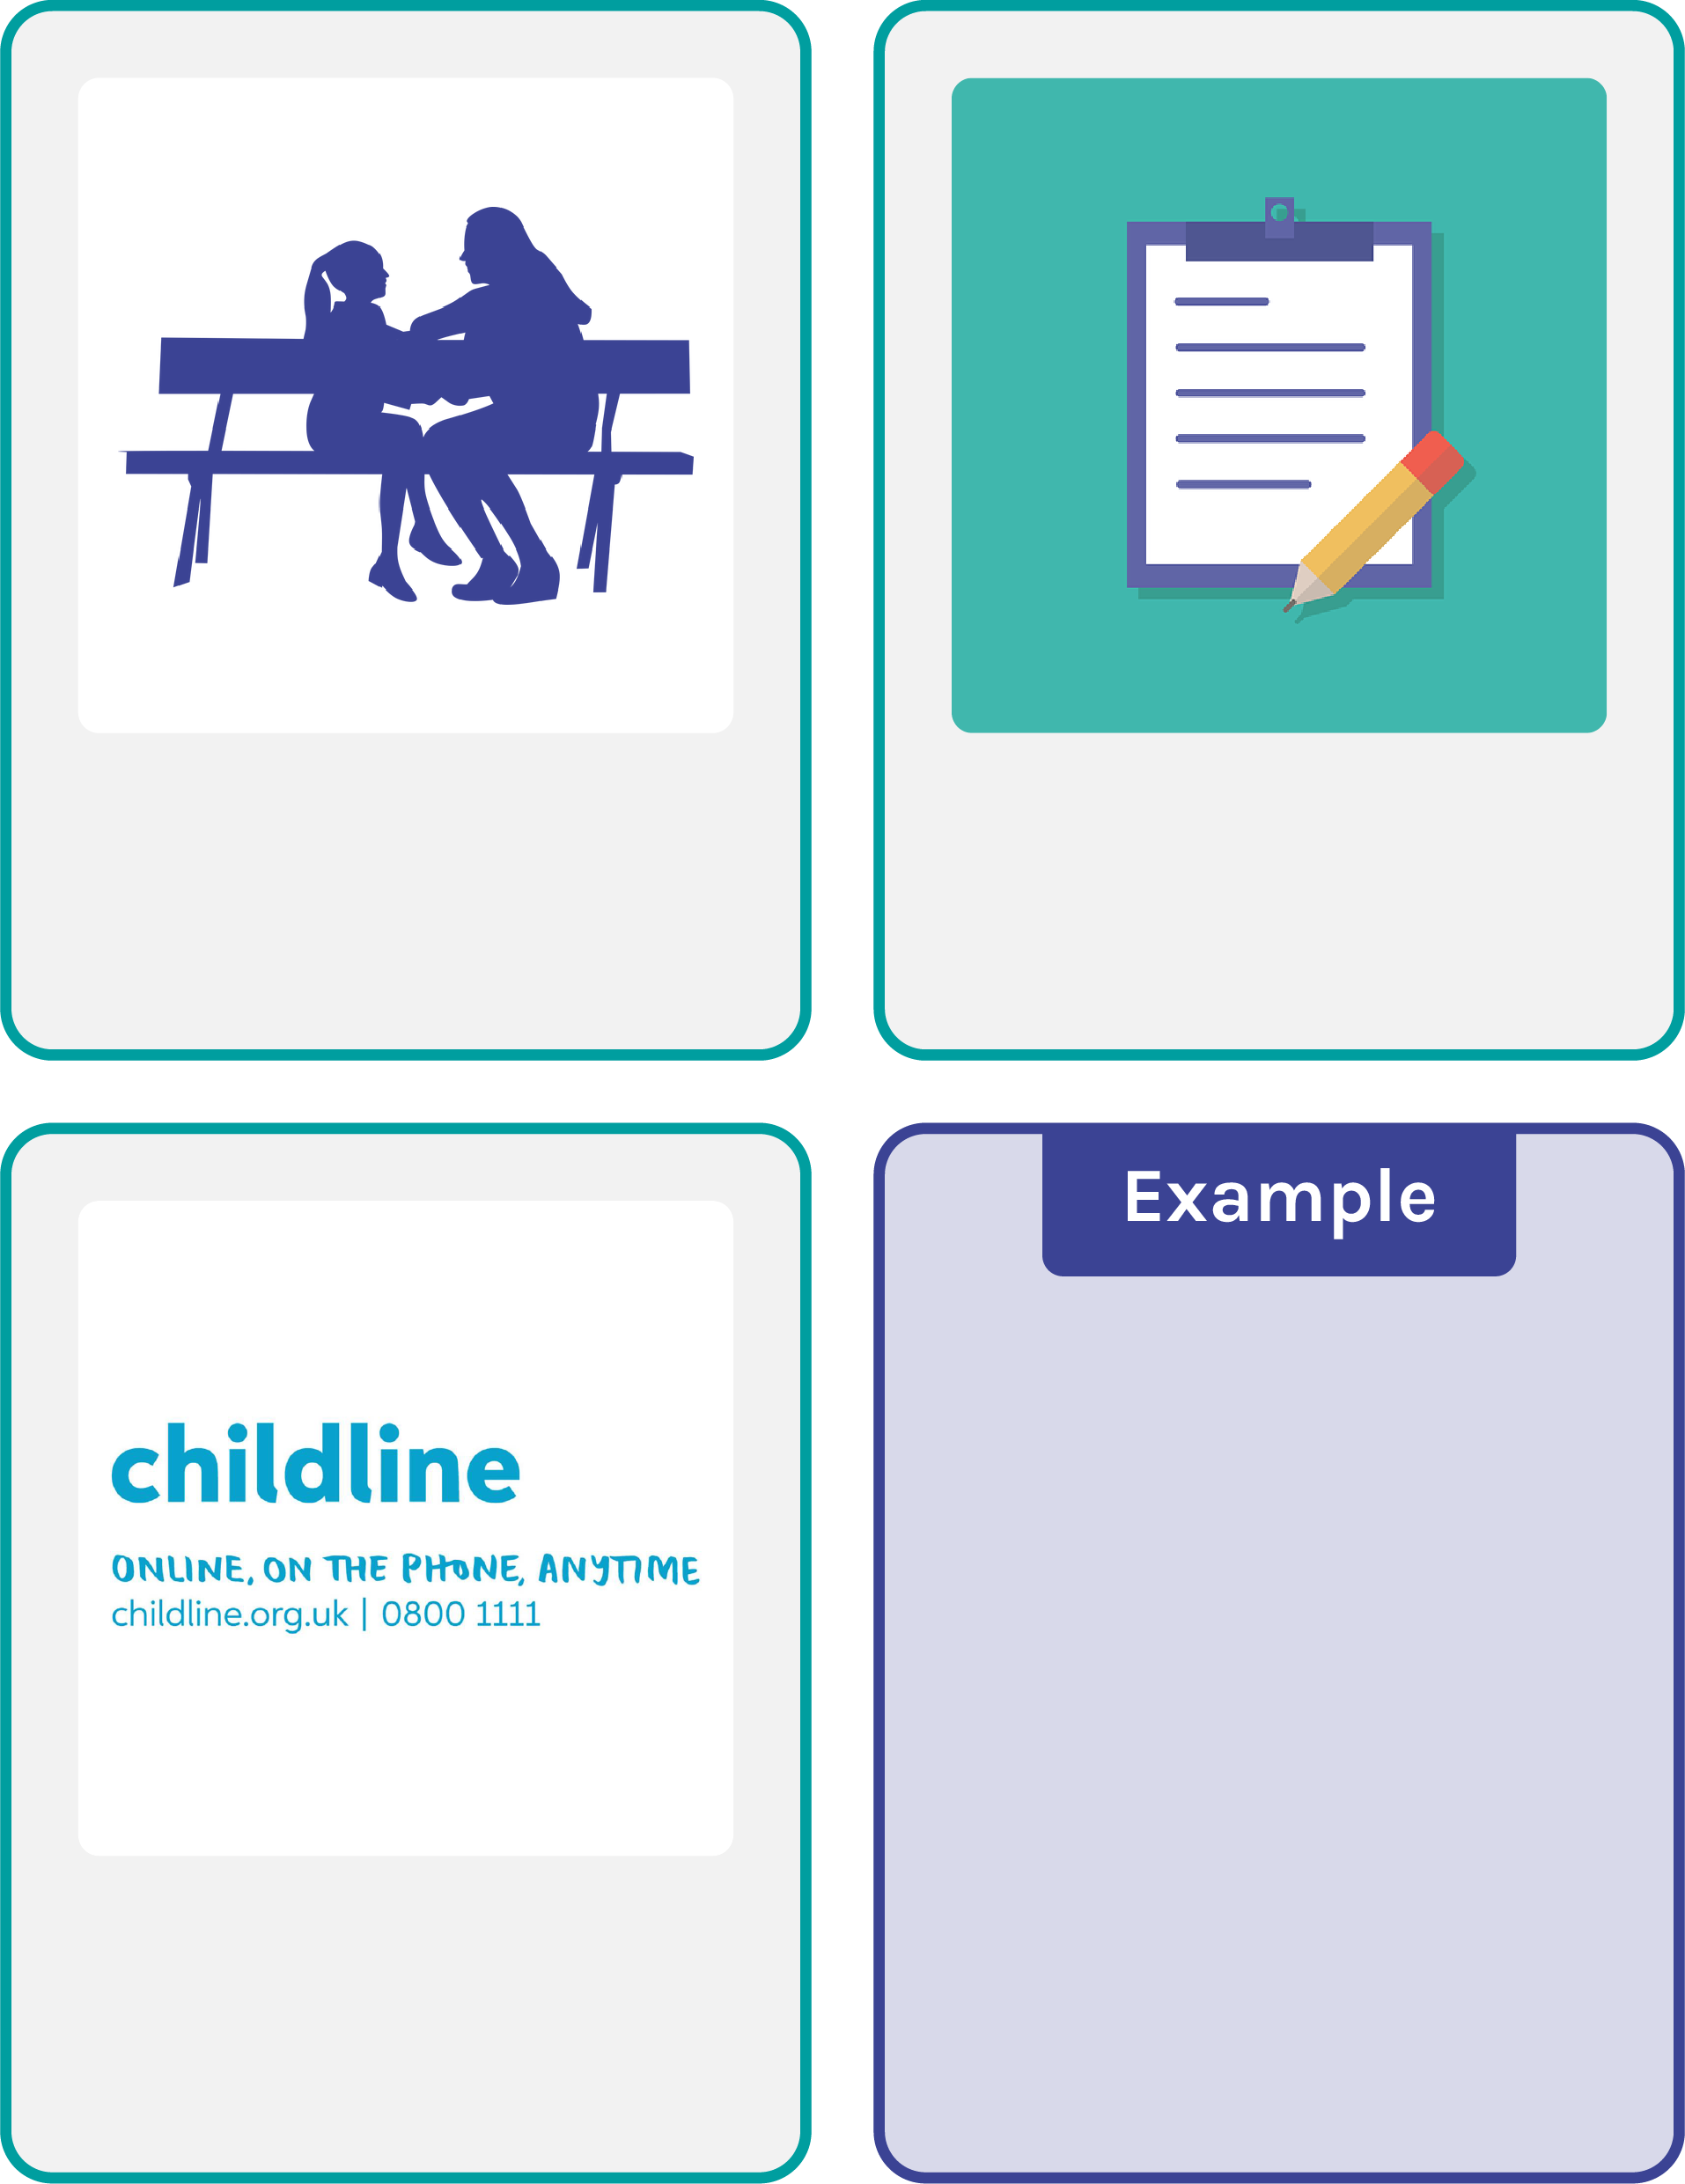

If a young person is worried about a study taking place in school, they could talk to a trusted adult like a teacher or form tutor.

Participant information sheets about a study usually say how to get further information if young people have questions.

If someone realises they need support about a topic being studied, there are support services that can help. These are often listed at the end of a study.

In the Smoking, Drinking and Drug Use among Young People in England survey the information leaflet for students tells young people how they can find out more about the survey and what support services are available.

**Resource 3: *Benefits and drawbacks card sort***

**Research might   
be about a topic   
a young person   
finds upsetting.**

**There might be fewer stereotypes about young people if research is available about their needs, interests and experiences.**

**Young people might have new ideas that adults haven’t considered before.**

**Young people’s needs are better understood if they can take part   
in research.**

**If there are interviews in a study and a researcher is from a different age group, it might feel uncomfortable to   
talk to them.**

**Someone might feel empowered to have their voice heard through research.**

**Research can take time and effort and young people have other responsibilities and activities they want to take part in.**

**Decision makers can make sure money   
is being spent in a   
way that helps   
young people.**

**Someone might feel that research is asking questions that are personal   
or private.**

**Young people aren’t   
a single group so diverse and unique experiences can be better understood through research.**

**Challenge:**

*Are there any other benefits or drawbacks?*



**Challenge:**

*Are there any other benefits or drawbacks?*

